Barcodes

# Item: Iphone 12

Barcode: 123456789 - 001

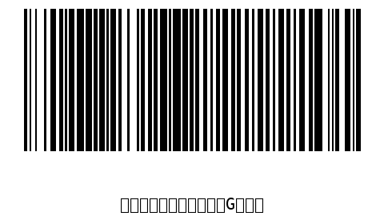

# Item: Tivi LG

Barcode: 987654321 - 002

